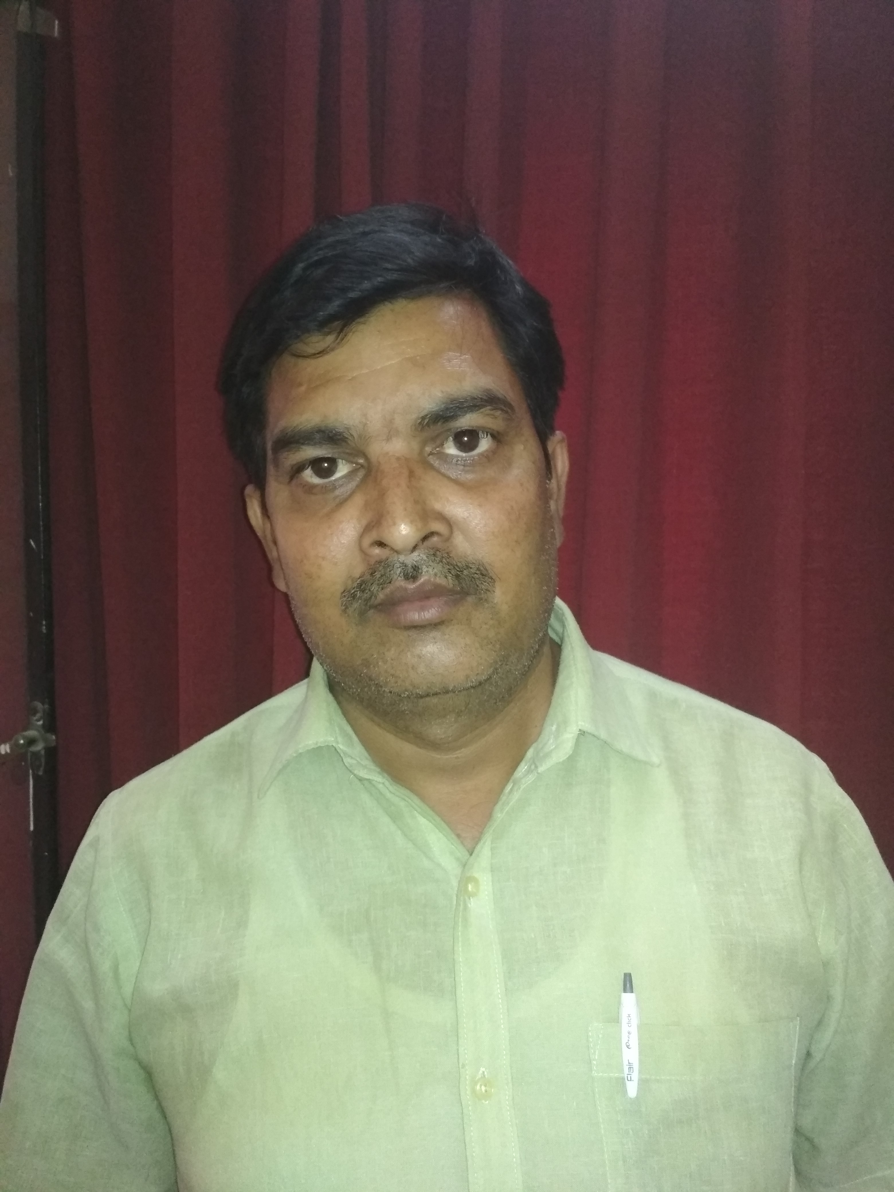
JECRC
Affix and Attest
passport
size photograph
JAIPUR

INDIVIDUAL TECHNICIAN DATA SHEET
Name of the Technical staff member | : | Narendra singh
Present Designation | : | Lab Instructor
Email Id: :nsinghjaipur@gmail.com
Contact Details :9782393951

I. Particulars of Educational Qualification: (only completed)

Category | Name of the Degree | Specialization | Year of Passing | Name of the College | Name of the University
Diploma | Diploma | Mechanical | 1995 | Town Polytechnic, Ballia | UPTE

II. Academic Experience : 14 Year

III. Industrial Experience :

